Experiment No: 3

Aim: Interfacing with Arduino uno - Buzzer, potentiometer, LED, Switch, Resistors

Objective:

1. Alternately turn ON / OFF the BUZZER

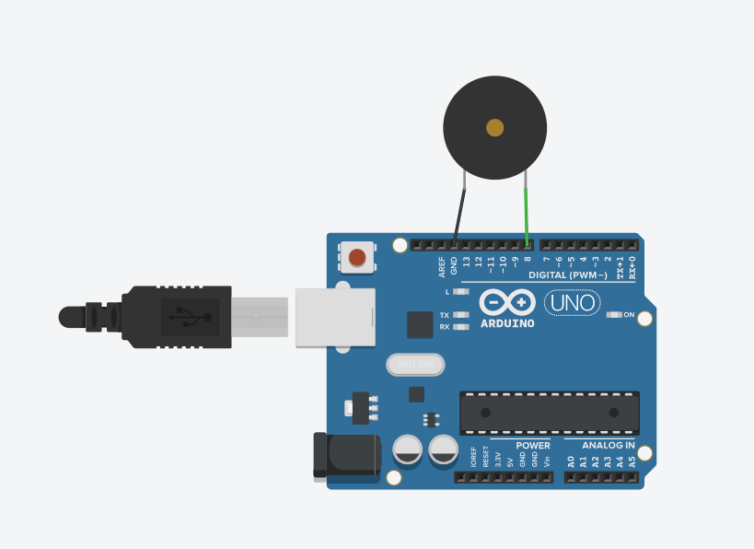

void setup()

{

pinMode(8, OUTPUT);

}

void loop()

{

digitalWrite(8,HIGH);

delay(2000);

digitalWrite(8,LOW);

delay(2000);

tone(8,440,5);

noTone(8);

}

1. Blink LED without using delay

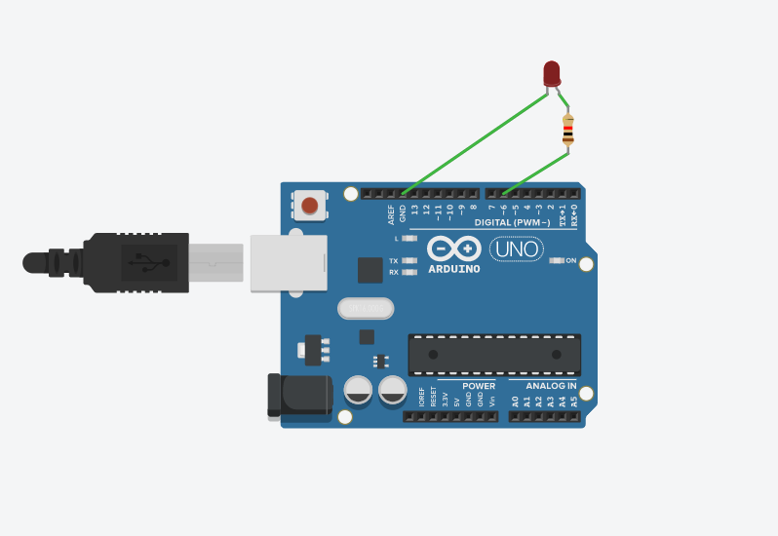

1. **int ledPin = 6;**
2. **int ledState = HIGH;**
3. **unsigned long previousMillis = 0; //it save time**
4. **long interval = 1000;**
5. **void setup() {**
6. **pinMode(ledPin, OUTPUT);**
7. **}**
8. **void loop()**
9. **{**
10. **unsigned long currentMillis = millis();**
11. **if (currentMillis - previousMillis >= interval) {**
12. **previousMillis = currentMillis;**
13. **if (ledState == HIGH)**
14. **{**
15. **ledState = LOW;**
16. **}**
17. **else**
18. **{**
19. **ledState = HIGH;**
20. **}**
21. **digitalWrite(ledPin, ledState);**
22. **}**

**}**

Demonstrate the use of input pull up

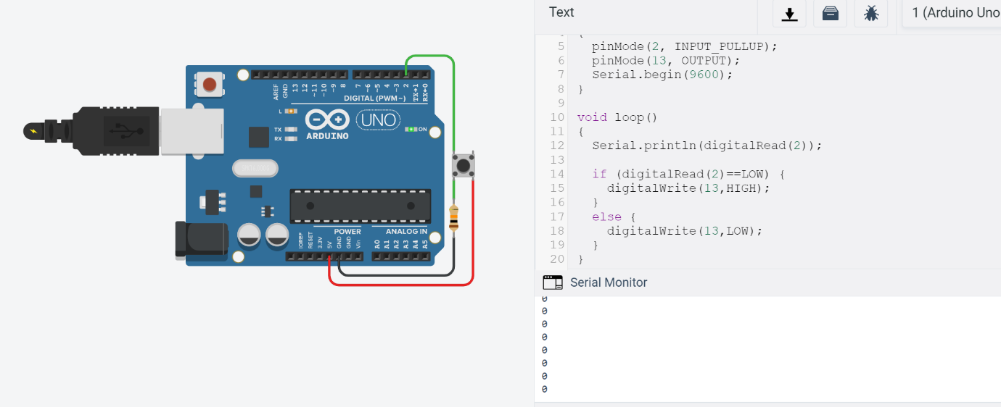

**void setup()**

**{**

**pinMode(2, INPUT_PULLUP);**

**pinMode(13, OUTPUT);**

**Serial.begin(9600);**

**}**

**void loop()**

**{**

**Serial.println(digitalRead(2));**

**if (digitalRead(2)==LOW) {**

**digitalWrite(13,HIGH);**

**}**

**else {**

**digitalWrite(13,LOW);**

**}**

**}**

Traffic signal using RGB

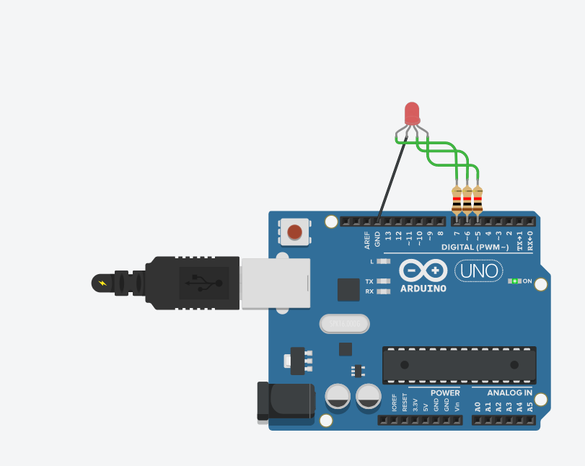

int pos=0;

void setup()

{

pinMode(7, OUTPUT);

pinMode(6, OUTPUT);

pinMode(5, OUTPUT);

}

void loop()

{

analogWrite(7,255);

analogWrite(6,0);

analogWrite(5,0);

delay(1000);

analogWrite(7,255);

analogWrite(6,0);

analogWrite(5,255);

delay(1000);

analogWrite(7,0);

analogWrite(6,0);

analogWrite(5,255);

delay(1000);

}

Control tone of buzzer with potentiometer

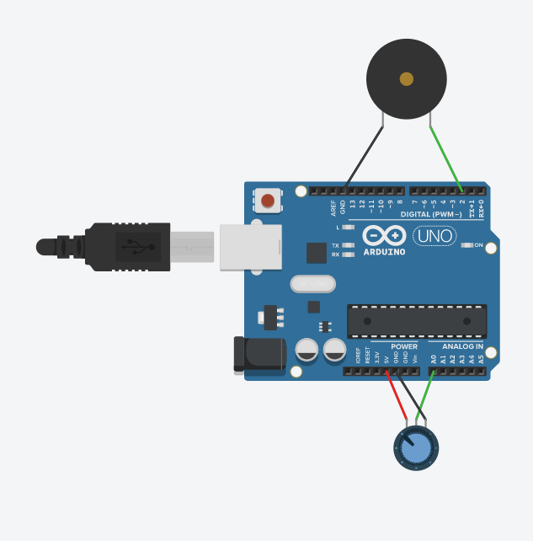

**int x=0;**

**void setup()**

**{**

**pinMode(2, OUTPUT);**

**pinMode(A0,INPUT);**

**}**

**void loop()**

**{**

**x=analogRead(A0);**

**tone(2,map(x,0,1023,120,1500));**

**Serial.println(A0);**

**delay(2);**

**}**

Play a tune when button is pressed

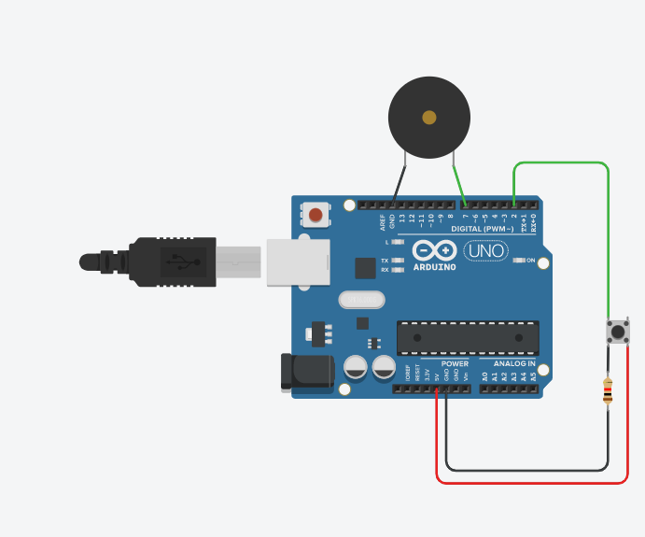

**int buttonState=0;**

**void setup()**

**{**

**pinMode(7, OUTPUT);**

**pinMode(2,INPUT);**

**}**

**void loop()**

**{**

**buttonState=digitalRead(2);**

**if(buttonState==1)**

**{**

**tone(7,440);**

**}**

**else**

**{**

**noTone(7);**

**}**

**delay(10);**

**}**

Traffic signal with a buzzer

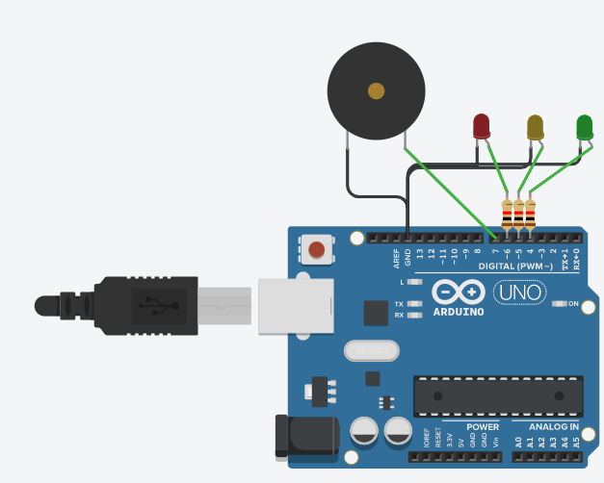

**void setup()**

**{**

**pinMode(7, OUTPUT);**

**pinMode(6, OUTPUT);**

**pinMode(5, OUTPUT);**

**pinMode(4, OUTPUT);**

**}**

**void loop()**

**{**

**digitalWrite(6, HIGH);**

**delay(4000);**

**digitalWrite(6, LOW);**

**tone(7,770);**

**delay(1500);**

**noTone(7);**

**for(int i=0;i<5;i++)**

**{**

**digitalWrite(5,HIGH);**

**delay(1000);**

**digitalWrite(5,LOW);**

**delay(1000);**

**}**

**digitalWrite(4,HIGH);**

**delay(4000);**

**digitalWrite(4,LOW);**

**tone(7,770);**

**delay(1500);**

**noTone(7);**

**}**